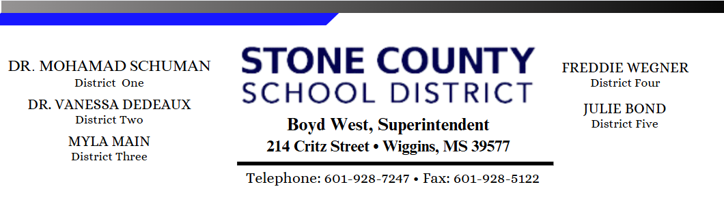
REQUEST TO INSPECT, COPY OR REPRODUCE PUBLIC RECORDS
Date: |  |  |  |  |  |  |  | Phone:
Person Requesting |  |  |  |  |  |  |  |  |  |  | Fax:
Business (if applicable):
If Attorney/Insurance company making request
Client’s Name:
Address:
SUBJECT MATTER:
(Any request shall be clear, concise and directed toward only one subject matter)
MATTER |  |  |  |  |  |  |  |  |  |  |  |  |  |  | Personally Inspect
OF COMPLIANCE |  |  |  |  |  |  |  |  |  |  |  |  |  |  | Photocopy of Document
MANNER |  |  |  |  |  |  |  |  |  |  |  |  |  |  | By mail to address above
OF DELIVERY |  |  |  |  |  |  |  |  |  |  |  |  |  |  | In person at your office
I understand that the actual cost of compliance with my request shall be borne by me, including mailing cost, if applicable. Actual cost of compliance with my request, if granted, shall be paid by me in advance of the receipt of any information.
 |  |  |  |  |  |  |  |  | SIGNATURE OF PERSON REQUESTING RECORDS
DO NOT WRITE BELOW
****************************************************************************************
ESTIMATE OF COST |  |  |  |  |  |  |  |  |  |  |  | =
TOTAL ESTIMATE |  |  |  |  |  |  |  |  |  |  |  | =
AMOUNT PAID |  |  |  |  |  |  |  |  |  |  |  | =
RECEIPT #
Date of Compliance |  |  |  |  |  |  |  |  |  | Department:

